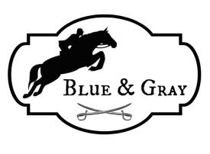
Bradley Caine Clinic April 23, 2023
Hosted by the Blue & Gray Circuit
at Lemaliza Farm 10820 McFarland Rd Mercersburg, PA 17236

Join us for a fantastic day of learning! Bradley Caine was originally based out of her family's Winter Place Farm in Salisbury, MD. There, she studied under and was coached by some of the industry's greatest horsemen and trainers such as Ronnie Beard, Nelson Pessoa, and George Morris. She and the team at Winter Place Farm showed many of the country's top hunters and jumpers to wins and championships at all of the major horse shows in the nation such as Devon, Washington International, and Harrisburg as well as many national championships. Her success ranged from winning in the pony hunter division on her pony, Checkmate, to producing Olympic caliber horses such as "Jet Run" and "Southside" (ridden by Robert Ridland in the Montreal Olympics).
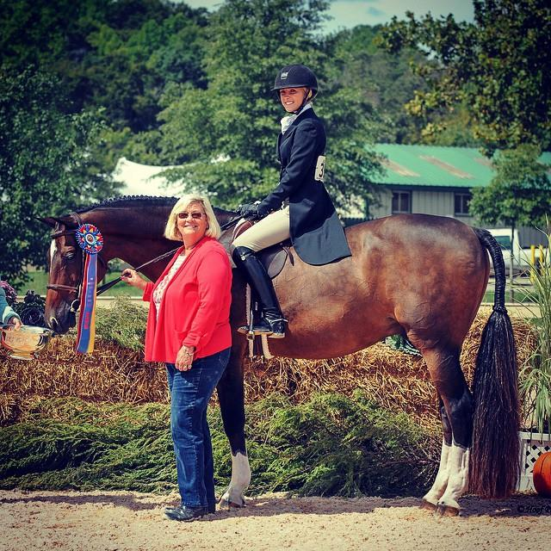
Bradley now devotes her time to traveling and giving clinics/lessons all over the East Coast. She still enjoys helping aspiring riders to better themselves, both at home and at horse shows. She is still coaching both at local and rated shows and traveling to Florida for the show circuit every years also a 'r' Hunter judge and Hunt Seat Equitation judge with USEF.
Clinic section numbers will be kept small (4-5 riders) to allow everyone to have a good experience. We will offer sessions for the following: Flat work (w/t/c), Crossrails (max 18”), 2’, and 2’6”. We will offer multiple sessions at each height as needed. There is ample space for auditors and riders waiting for their slots to watch. Please bring your own chairs! Coffee, water, and some light snacks will be provided. Participants are responsible for their own lunch.
The cost of the clinic is as follows:
Early entry discount: Riders $75.00 Auditors $20.00
After March 15: Riders $95.00 Auditors $25.00
All riders may have one free spot for an auditor. Please fill out the enclosed form and submit with payment. We will accept clinic entries until March 30, or until all spots are filled. Watch for more information and updates!

Clinic Registration Form
Name __________________________________________________ Age___________________
Address_______________________________________________________________________
City ____________________________________________State__________________________
Zip ___________________________Phone #_________________________________________
E-Mail_________________________________________________________________________
Preferred time : ______ Morning _____ Afternoon
Mark session height:
_____ Flat work (w/t/c) _____ 2’
_____ Crossrails _____ 2’6”
A current Coggins test is required for all horses attending the clinic. Riders must also provide documentation of current EIV and EHV (flu and rhino) vaccinations and sign a release form before riding. (Parent/guardian must sign if rider is under 18)
Please send form and payment to reserve your spot.
Checks should be made payable to the Blue & Gray Circuit. Forms may be emailed to bluegrayhorseshows@outlook.com. Contact us for more details.
Forms and checks may also be mailed to:
Lori Swanson
2246 Newville Road
Carlisle, PA 17015

Office Use Only Session Time ___________________________
Payment |  | Coggins
Signed Release |  | Flu/Rhino proof

WAIVER AND RELEASE: Every entry shall constitute an agreement and affirmation that all participants (which include, without limitation, the owner, lessee, trainer, manager, agents, friends, rider, handler and/or horse), for themselves, their principals representatives, employees, and/or agents, shall agree that they participate voluntarily in the competition, fully aware that horse sports and competition involve inherent dangerous risk of serious injury and/or death, and by participating they expressly assume any and all risks of injury, sickness and disease (including communicable diseases), or loss, and they agree to indemnify and hold the property owners, the Blue and Gray Horse Show Circuit, all farms and Clubs affiliated with the Blue and Gray Horse Show Circuit, volunteers, and/or agents harmless from and against all claims, including any injury or loss suffered during, or in connection with the competition, whether or no such claims, injury or loss resulted directly or indirectly, from the negligent acts or omissions of said officials, owners, volunteers or agents of the Blue and Gray Horse Show Circuit or affiliated farms and riding clubs associated with the Blue and Gray Horse Show Circuit. REMEMBER THIS ENTRY FORM SERVES AS A RELEASE. BY SIGNING THIS YOU ARE AGREEING TO ASSUME THE RISK OF EQUINE ACTIVITIES PURSUANT TO PENNSYLVANIA LAW I HAVE CAREFULLY READ THIS DOCUMENT IN ITS ENTIRETY, UNDERSTAND ALL OF ITS TERMS AND CONDITIONS, AND KNOW IT CONTAINS AN ASSUMPTION OF RISK, RELEASE AND WAIVER FROM LIABILITY, AS WELL AS A HOLD HARMLESS AND INDEMNIFICATION OBLIGATIONS.

Rider Name: _________________________________________________

Signature: ___________________________________________________

Date: ______/________/ 2023

